Are DACA Recipients living in states filled with opportunity?

Economics 305: Research Paper (First Draft)

Juan Villegas

03/31/2022

Table of Contents

The Difference Between A DACA Recipient & A Dreamer 3

Pros & Cons of DACA 3

Thesis 4

Geographical Characteristics About DACA Recipients 4

DACA Students in Higher Education 7

Undocumented Students in Higher Education How Many Students are in U.S. Colleges and Universities, and Who Are They? 7

College statistics by state 8

The dataset: What variables will I be looking for? What Am I measuring? 9

Lock out States 10

College related predictor variables 11

State characteristics related predictor variables 11

Economical Predictor Variables 11

Regression Models: Removing Multicollinearity 12

College Related Predictor Variables: Scatterplots + Regressions 20

State Related Predictor Variables: Scatterplots + Regressions 25

Economical Related Predictor Variables: Scatterplots + Regressions 29

Conclusion 32

# The Difference Between A DACA Recipient & A Dreamer

DACA and Dreamers… They’re the same thing, right? No. The term ‘Dreamers’ has 2 connotations. The first (and O.G.) connotation is an acronym for a United States legislative proposal to grant temporary conditional residency to undocumented immigrants who entered the United States as minors. The proposal was called, ‘The Development, Relief, and Education for Alien Minors’ (**DREAM Act**), and it would’ve given young qualified undocumented individuals the right to work and eventually attain permanent residency. Sounds reasonable right? We’ll, the bill was introduced on April 2001 and it did not pass. This bill was continuously modified and re-introduced to senate almost yearly from 2001 to 2011 but it always failed... Until 2012. In 2012 a policy was introduced and passed: Deferred Action for Childhood Arrivals (DACA). This policy gives qualified undocumented individuals the chance to a renewable two-year period of deferred action from deportation and a limited employment authorization document (work permit) plus a ‘Work Only’ SSN (that costs $500 per renewal).

This is where the second connotation of “DREAMER” comes in. The word ‘Dreamer’ is now used to describe undocumented immigrants who were brought to the United States as children, who live and attend school here, and identify as American… but aren’t actual citizens. It has a double meaning about the undocumented youth who have hopes and dreams for a better future.

## Pros & Cons of DACA

DACA is a reasonable policy; It gives recipients the chance to work in **most** companies, apply for driver licenses and credit cards (to build credit and put utility bills under there name), and the ability to be recognized for the economical footprint they’re making in the U.S.. It does however have its cons: recipients aren’t given a direct path towards citizenship (other than marriage or being sponsored by a company), attending secondary education is an obstacle: financial aid and some scholarships require citizenship, governmental jobs are prohibited (to anyone who isn’t a citizen), and lastly, recipients have no security: DACA can be terminated at any given moment meaning that recipients can lose all the listed pros at any moment.

## Thesis

My obsession with DACA recipients, brings me to the topic of this research paper. I want to gain insights and understand the characteristics of the states that DACA recipients live in. As of December 2021, there is a total of 611,470 DACA recipients living in the United States. California and Texas are the states with the greatest number of DACA recipients (174,688 and 101,350) by a land slide and they’re also the states with the greatest number of estimated immediately DACA eligible population (343,000 and 208,000). I need to know if these recipients are in these states because of the geographical location and how close they are to Latin America or if there are underlying characteristics about certain states that have driven recipients to locate elsewhere. I would love to learn that DACA recipients are living in states where a bunch of S&P 500 companies are located, or states where they can receive the most opportunity to propel their lives. Like living in a state surrounded by big companies to sponsor them into becoming citizens.

# Geographical Characteristics About DACA Recipients

Before I commence to tell you about how I extracted data to conduct my study, I want to state some statistics I’ve learned about DACA recipients and where they’re located. I used the USCIS website to acquire a dataset that gave me characteristics about DACA recipients like how many came from certain countries, how many live in each state, how many are between certain ages, and other qualitative statistics. I created the figures/tables 0 and 1 so that you can see a visualization of all this.

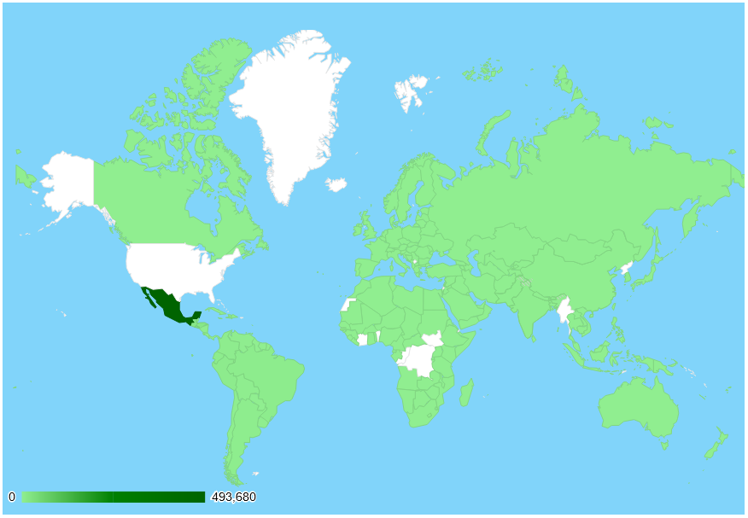Figure 0: This figure shows a map of the whole world with an overlay of DACA recipients by Country of Birth

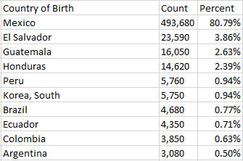Table 0: Shows the top 10 countries that DACA recipients are from

Looking at Table and figure 0, we can see how much more Mexican DACA recipients there are than any other country. The first four countries in the table are from Central America. The rest of the top 10 countries of DACA, excluding South & North Korea, are from South America. This can have a significant impact regarding where DACA recipients live in the United States.

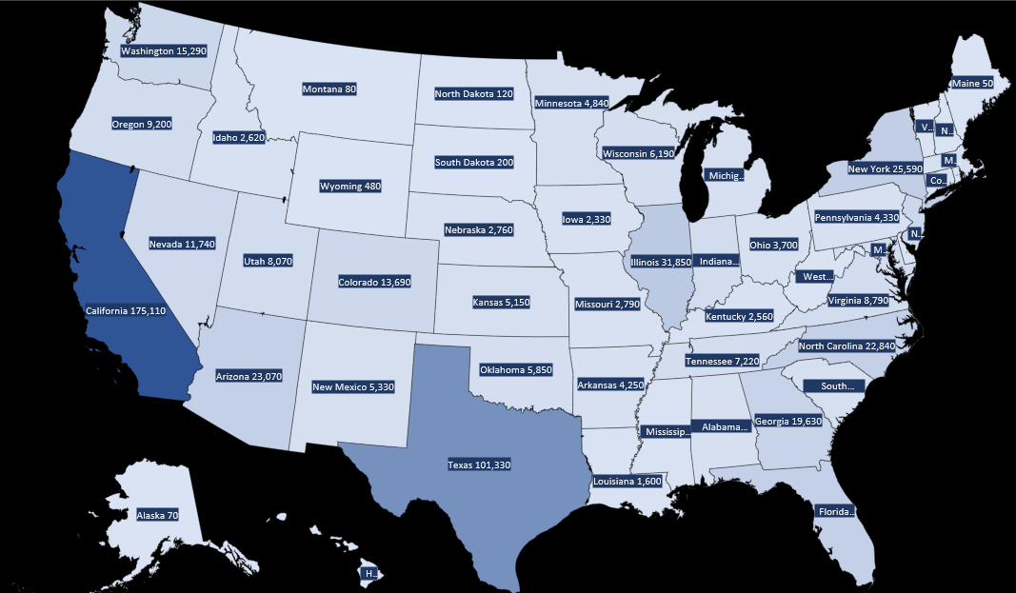Figure 1: Shows a map of the United States with an overlay of DACA.

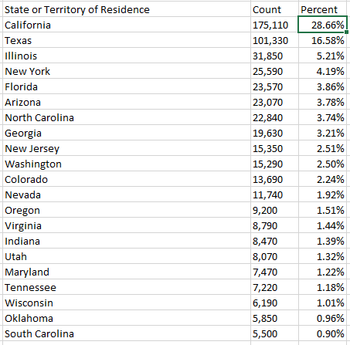Table 1: Shows the top 20 States with an overlay of DACA.

Table and figure 1, show us how the proportion of DACA individuals and how they are dispersed throughout the United States. Table 1 easily illustrates to us that California and Texas are the only states with more than 10% of the DACA population. After that, the population of DACA are distributed fairly low. After the 19th state, the population is distributed by less than 1% for each state. The states Illinois and New York are also interesting. This is interesting because these states are not close to the Mexican border.

# DACA Students in Higher Education

DACA’s 10th year anniversary is this year. Evidentially there has been research done on DACA recipients on how they’ve progressed throughout these 10 years. My research question has to do with recipients locating in states that are filled with opportunity. During my research phase, I came across a lit review called, “Undocumented Students in Higher Education. How Many Students are in U.S. Colleges and Universities, and Who Are They?”, by Presidents’ Alliance. From this Lit review, I discovered some interesting facts regarding the college age recipients.

## Undocumented Students in Higher Education How Many Students are in U.S. Colleges and Universities, and Who Are They?

In Presidents Alliance lit review, some underwhelming statistics about DACA and undocumented students are introduced. It’s stated that undocumented students only account for about 2 percent (approx. 427,000) of all students in higher education in the United States. DACA/DACA-Eligible students (that are also considered undocumented students) represent 0.8 percent (approx. 181,000 students) of all students in higher education. To find out the percentage of DACA recipients that attend secondary education. We divide the 181,000 DACA recipients in secondary education from our overall population of 611,470 DACA recipients. This means that almost 30% of recipients attend secondary education (181,000/611,470 = 0.2960). This percentage of recipients is extremely low but, Presidents Alliance provides their explanation as to why the numbers are low.

“Why Numbers Are Different From 2018”, is the section in the lit review that breaks it down for us. This section states that from the year 2018 to 2021, the undocumented student population decreased by 5.1 percent, and the DACA/DACA-eligible student population decreased by 16.2 percent. President Alliance blames: strict immigration policies from the previous (trump) administration, the challenging political atmosphere, adjustment of status (especially among DACA-eligible individuals), and the rising cost of higher education in the United States as influencers as to why the secondary education – undocumented students’ trend has declined. All the reason Presidents Alliance mentioned make sense, the Trump presidential campaign did intimidate the undocumented community so it would make sense if some recipients did not invest their money into education, when they could potentially be deported.

What also stands out the is the phrase “rising cost of higher education in the U.S.” DACA recipients don’t receive financial aid in some states and other states prohibit DACA students from attending their public colleges all together. What about the states that offer some sort of in-state tuition benefits and financial assistance? This could be interesting to keep in mind moving forward.

## College statistics by state

The end of this research literature review shows the reader a table of undocumented and DACA students in higher education by state. This table proves helpful for my research paper because it shows us 5 states with actual counts for DACA recipients attending colleges.

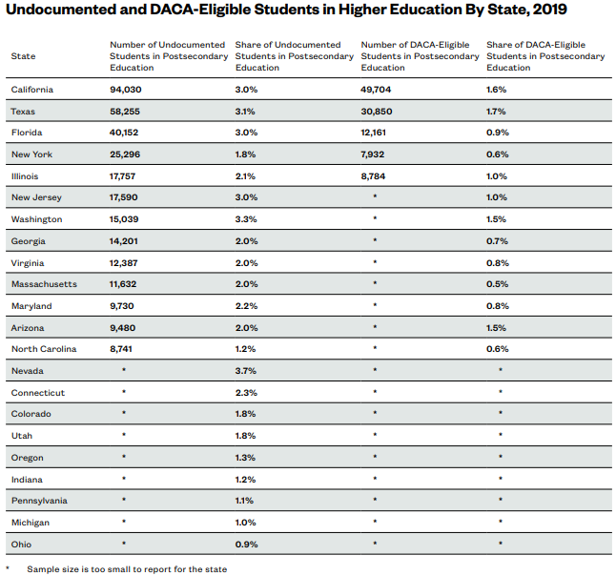

Table 2: shows the # & %of DACA & undocumented students in each state (Anti-Defamation League, ##/##)

Even though, less than a third of my population attends college, I believe that there can be a significant association between the colleges’ states and where DACA students are residing in the U.S.

# The dataset: What variables will I be looking for? What Am I measuring?

First and foremost, I grabbed the ‘Active DACA Recipients– December 2021’ data set from USCIS. From this file, I was able to extract the number of DACA recipients in each of the 51 states and make the graphical displays seen above. The next thing I did was grab the variables “States” and “DACA Recipients in each state” and put those in a new Excel sheet. From there, I went online and researched some predictor variables that could be significant to a DACA recipients location regarding economic opportunity.

## Lock out States

My first foreign encounter while researching for predictor variables was the term Lock out state. CollegeExpress, a college search and planning website, considers states that make it a challenge **financially** for undocumented students (by charging out-of-state or international tuition rates) to attend college, Lock out States. The issue with this definition for ‘lock out states’ is that it doesn’t consider some states, like Alabama and South Carolina, that prohibit undocumented students from enrolling in their public institutions.

TheDream.US, An organization that provides more than 6,000 DACA, TPS, and undocumented qualified students the opportunity to attend college on full tuition or full tuition and room & board scholarships, considers a lot more states as Lock out States. The Dream.US considers states that do not provide in-state tuition rates, financial aid, and prohibit undocumented students from attending state universities lock out states.

This means that 20 states (Alabama, Alaska, Arkansas, Georgia, Idaho, Indiana, Iowa, Louisiana, Maine, Massachusetts, Mississippi, Missouri, New Hampshire, North Carolina, North Dakota, Ohio, South Carolina, South Dakota, West Virginia, and Wisconsin) are considered locked states. I will consider these states as ‘Lock out states’ for my Data set. 0 will mean that the state is locked. 1 will state that the state is not locked.

## College related predictor variables

Continuing the subject of college, I extracted predictor variables from all over the web that have to do with college and each state. These variables include: the average secondary education student population, the tuition rates for in and out of state residents, the amount of public and private secondary education institutions per state, the graduation proportion of these schools (I had to convert the percentages into proportions so STATA could read my data), the average student to faculty ration per state, the average acceptance proportion of all the colleges per state, and the average annual salary post-secondary education.

## State characteristics related predictor variables

To shift more to State specific characteristics, I decided to focus on certain characteristics that I believe can be appealing to DACA recipients. Considering that the majority of DACA recipients are from Latin America, I made these variables very Latinx bias. I extracted information on the # of Spanish speakers by each state, the number of undocumented individuals per state, the average temperature per year for each state, whether a state is a locked state and the proportion of republicans and democrats within each state.

## Economical Predictor Variables

The last set of predictor variables I decided to incorporate in my dataset revolved around the opportunity. According to U.S. News, opportunity is calculated from 3 aspects divided equally: Affordability (which measures the cost of living and housing affordability), Economic Opportunity (which tracks income inequality, median household income, # of people in poverty and food insecurity rates) and Equality (which measures gender parity, racial inequality in education rates, income and unemployment rates). For my data set, I extracted information regarding each states: poverty #’s, the cost of living and housing index (Index is measured by how far from 100 a number is, that’s the percent difference from the national average… for example Hawaii’s living index is 196.3. This means that the cost of living in Hawaii is 96.3% higher than the U.S. average.), and the median household income by state.

# Regression Models: Removing Multicollinearity

My first step in my regression models is to create regression models for predictor variable and target variable (# of DACA Recipients per state) for my 3 categories (Economical, State Characteristics, College related) that aren’t too highly correlated. I will use a correlation table so that I can decide what variables have high multicollinearity. I will solve multicollinearity problems by choosing one variable to create an analysis on instead of whatever predictor variables can be multicollinear.

I am taking these procedures to multicollinear variables because multicollinear variables cause

coefficients to become very sensitive to small changes in the model. Multicollinearity also reduces the precision of the estimated coefficients, which weakens the statistical power of our regression model.

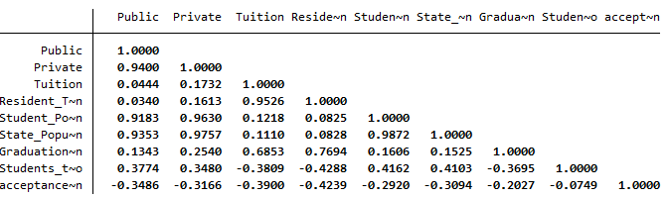

Table 3: Correlation table of college related predictor variables: # of private & public universities, tuition and resident rates, student population, state population, graduation proportion, student to faculty ratio, and acceptance proportion.

From this table 3, I made the decision to disregard the variables ‘number of public & private universities’ and ‘student population’. We can assume that the number of public & private universities and student population is associated with how state population. If a state has a bigger population, it’ll have more schools (private or public) … and if a state has more schools, it’ll have a more students in its population (Figure 3). Another highly correlated variable is Resident tuition and tuition. Figure 4 shows: when tuition rates rise, so does the residential tuition rate. I will focus on the variables State population, student to faculty ratio, tuition, and graduation proportion.

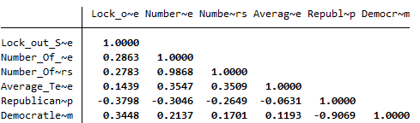

Table 4: Correlation table of State related predictor variables: Locked States, # of undocumented people, # of Spanish speakers, average state temperatures, republican ratio, democratic ratio

Table 4 shows us that ‘# of undocumented people’ and ‘# of Spanish speakers’ is highly correlated. I removed ‘# of Spanish speakers’ and # of undocumented people as predictor variable because both these groups tend to be immigrants from a different country and Immigrants can technically be undocumented people. Figure 5 shows a scatterplot of ‘# of undocumented people’ and ‘# of Spanish speakers’. The variable Republic proportion and democratic proportion are also very highly correlated. I decided to make a regression model on: Republican and Democrats to see if these variables had any actual significance. Table 6 shows each regression model. This table also shows that none of these variables are statistically insignificant (p-value is not less than .05). The smallest p-value we received from these 3 variables was a .1 and it does not meet my threshold of .05 to be significant. The variables I will examine for state related predictor variables are: AVG state temperature, locked states.

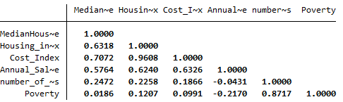

Table 5: Correlation table of Economic related predictor variables: Annual Salary after college, Cost Index, Housing Index, Median household Income

Table 5 Show that the only collinear variables are cost index with housing index and median household income with cost index. Figure 6 & 7 shows just how closely correlated the cost index is housing index and median household income. I’m going to remove median household income and the housing index because these two variables are directly correlated with the cost index of a state. I will use # of people in Poverty, Cost Index, Annual Salaries after college, and number of S&P companies in a state as predictor variables.



Figure 3: Shows a scatterplot with a LSRL of Student Population on State population.



Figure 4: Shows a scatterplot with a LSRL of tuition on residential tuition.



Figure 5 shows a scatterplot of # of Spanish speakers on $ of undocumented people in a state

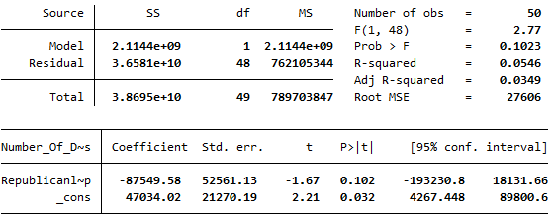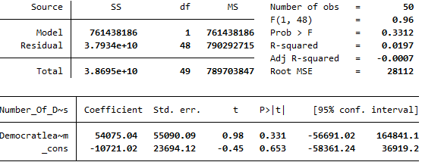

Table 6 shows 2 regression models. #1 # of Daca Recipients per state vs republican proportion. #2 # of Daca Recipients per state vs Democrat proportion



Figure 6 shows a scatterplot of housing index on cost index with a LRSL.



Figure 7 shows a scatterplot of Median Household income on cost index with a LRSL.

## College Related Predictor Variables: Scatterplots + Regressions

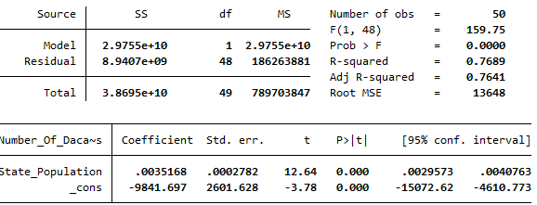

Table 7: Shows a regression model of State Population and # of DACA Recipients per state



Figure 8: Shows a scatterplot with a LSRL of state population on # of DACA Recipients per state.

Table 7 proves that there is an association between the # of DACA recipients per state and state population. Figure 8 shows that as the # of DACA recipients per state increase, the state population increases. Since state population is associated with ‘# of student population’ and the amount of private & public schools, we can interpret that: If DACA recipients live in highly populated states, they also live in states with a high number of universities & student population. Since most of the points on the plot are on the lower left of the screen, that means that most DACA recipients live in states with small population.

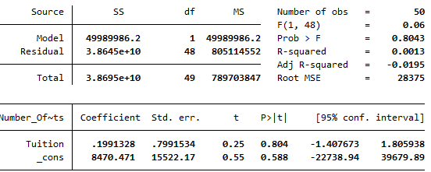

Table 8: This table shows that there is no statistical significance between tuition and # of DACA recipients per state



Figure 9: Shows a scatterplot with a LSRL of tuition on the number of DACA recipients per state.

Figure 9 shows that DACA recipients per state and tuition are not associated. The tuition rate remained constant whether there is a high population of DACA recipients per state in certain states or not.

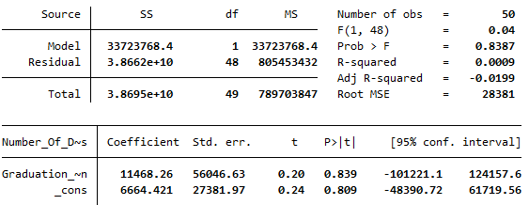

Table 9: This table shows that there is no statistical significance between graduation proportion and # of DACA recipients per state



Figure 10: Shows a scatterplot with a LSRL of graduation proportion on the number of DACA recipients per state.

Figure 10 shows that DACA recipients per state and graduation proportion are not associated. Graduation proportion remained constant whether there was a high population of DACA recipients per state in certain states or not.

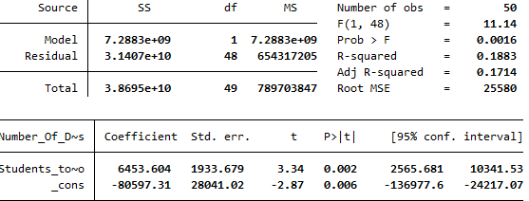

Table 10: This table shows that there is a statistical significance between student to faculty ratio and # of DACA recipients per state



Figure 11: Shows a scatterplot with a LSRL of student to faculty proportion on the number of DACA recipients per state.

Figure 11 & Table 10 show that there is statistical significance between student to faculty ratio and the number of DACA recipients per state in a state. This means that as the student to faculty ratio increases, the amount of DACA recipients per state in certain states also increase. We can almost interpret this as: As the state population increases, the student to faculty ration increases as well because as the number of DACA recipients per state increase… so does the population of the state.

## State Related Predictor Variables: Scatterplots + Regressions

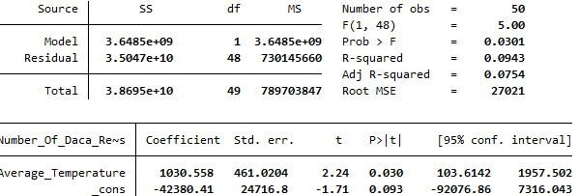

Table 11: Regression model of Average temperature and DACA recipient



Figure 12: Scatterplot of AVG temp on # of DACA recipients per state

From Figure 12 and table 11, we can make the assumption that there is an associate between AVG tempature of a state and the # of DACA recipients per state in a State. I can only assume that this is directly correlated with regional location of state that have hotter tempatures. States with higher tempatures tend to be in the south. The south is closer to the Mexican border and a majoritiy of DACA recipients per state come from Mexico.

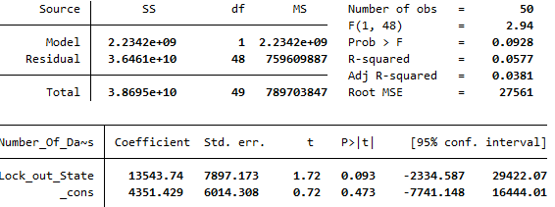

Table 12: regression model of lock out states on DACA recipients per state



Figure 13: Scatterplot of lock out states and DACA recipients per state

Figure 13 and table 12 can be hard to understand but, it is noticeable that a higher proportion of DACA recipient states in locked out states. Table 12 also shows that there is a significance in DACA recipients per state in locked states. When DACA recipients per state are in Locked states, the # of DACA recipients per state increases by 13543.74. DACA recipients per state tend to be in states that are not locked.

## Economical Related Predictor Variables: Scatterplots + Regressions

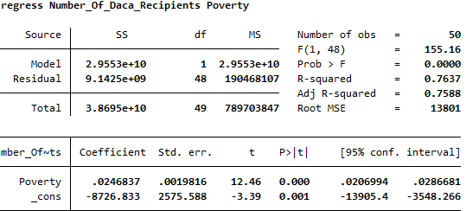

Table 13: Regression Model of # of people in Poverty on # DACA recipients per state

From Table 13, I can understand that # of people in poverty and DACA recipients per state have an association. It is understood that as the number of people in poverty goes up, the number of DACA recipients per state in a state also goes up. I believe this is because of state population. If a population has more people, it makes sense that more people will be in poverty.

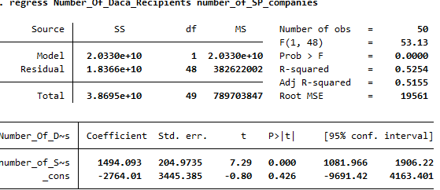

Table 14: Regression Model of # of S&P companies on # DACA recipients per state

From Table 14, I can understand that # S&P companies and DACA recipients per state have an association. It is understood that as the number of S&P companies in a state goes up, the number of DACA recipients per state in a state also goes up. I believe this is because state population as well. If a state has more S&P companies, it makes sense that the population be bigger.

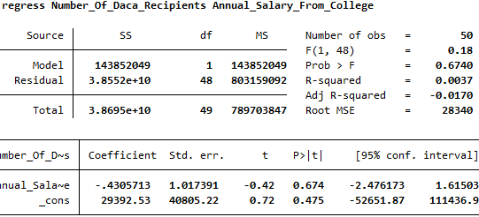

Table 15: Regression model of Annual Salary From College on DACA recipients per state

From Table 15, I can understand that Annual Salary from college and # of DACA recipients per state in a state do not have an association.



Figure 15: Scatterplot of Annual Salary from college on # of DACA recipients per.

Figure 15 proves this because it shows that as the # of DACA recipients in a state goes up, the Annual Salary from College is constant.

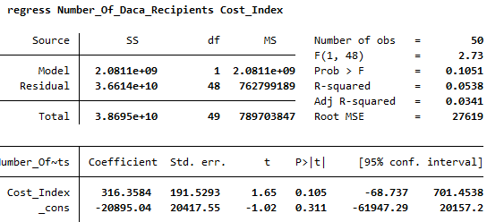

Table 16: Regression model of Annual Salary from College on DACA recipients per state



Figure 15: Scatterplot of Annual Salary from college on # of DACA recipients per.

Figure 15 and table 16 shows us that there is no association between # of DACA recipients per state and the cost index. Weirdly enough, there scatterplot does show an outlier with a small # of DACA recipients in a particular state with a high cost index.

# Conclusion

After looking at all the regressions and scatterplots, it is evident that a majority of DACA recipients per state tend to be in the states that they are in because of regional location. It is mere coincidence that a higher proportion of DACA recipients tend to live states filled with more universities and other economic opportunities. These highly populated states give a wider variety of DACA individuals the opportunity of more S&P Companies and hotter weather but, this is only because the states down south tend to be more heavily populated than the states in the mid part of the U.S. and everywhere else. It was fun to learn that DACA recipients are yet to move to states with more economical opportunity because they facts rather than sheer coincidence. High proportions of DACA recipients do in fact live in states with good opportunity and I was every single one of them the best. Next time when I conduct a research report, I will make sure that I fix a lot mistakes that I committed while making this report. The first mistake was adding too many variables to my data frame I analyzed. I became tunneled vision in making sure I had a good amount of variables to pick from and I forgot to eliminate them once I realized they weren’t useful. A lot of the variables I picked had a strong association with the amount of population within the states… to combat this I should made a lot of my predictor variables: proportions to the population. Making these predictor variables proportions would’ve made It easier for me to see what states had bigger proportions of what (poverty, graduation rates, S&P companies) and this would’ve helped with my analysis by eliminating a lot of population related bias.

References

Cost of living index by state 2022. (n.d.). Retrieved March 31, 2022, from https://worldpopulationreview.com/state-rankings/cost-of-living-index-by-state

Cphalpert. (n.d.). *Census-regions/US census bureau regions and divisions.csv at master · CPHALPERT/Census-Regions*. GitHub. Retrieved March 31, 2022, from https://github.com/cphalpert/census-regions/blob/master/us%20census%20bureau%20regions%20and%20divisions.csv

DACA analytics. (n.d.). Retrieved March 31, 2022, from https://joelhmarquez.com/dacaanalytics/#/population

*Immigration and Citizenship Data*. USCIS. (2022, March 9). Retrieved March 31, 2022, from https://www.uscis.gov/tools/reports-and-studies/immigration-and-citizenship-data

Median household income by state 2022. (n.d.). Retrieved March 31, 2022, from https://worldpopulationreview.com/state-rankings/median-household-income-by-state

*Overall best states rankings | US news best states*. (n.d.). Retrieved March 31, 2022, from https://www.usnews.com/news/best-states/rankings

*Poverty*. USDA ERS - Data Products. (n.d.). Retrieved March 31, 2022, from https://data.ers.usda.gov/reports.aspx?ID=17826

*Q: What is the average college grads salary by state in 2022?* (n.d.). Retrieved March 31, 2022, from https://www.ziprecruiter.com/Salaries/What-Is-the-Average-College-Grads-Salary-by-State

*Religious landscape study*. Pew Research Center's Religion & Public Life Project. (2022, March 31). Retrieved March 31, 2022, from https://www.pewforum.org/religious-landscape-study/compare/party-affiliation/by/state/

*The top five benefits of DACA: Apply with road to status*. Road to Status™. (2017, October 14). Retrieved March 31, 2022, from https://www.roadtostatus.com/top-5-benefits-of-daca/

*What is DACA and who are the dreamers?* Anti-Defamation League. (n.d.). Retrieved March 31, 2022, from https://www.adl.org/education/resources/tools-and-strategies/table-talk/what-is-daca-and-who-are-the-dreamers

*What is DACA and who are the dreamers?* Anti-Defamation League. (n.d.). Retrieved March 31, 2022, from https://www.adl.org/education/resources/tools-and-strategies/table-talk/what-is-daca-and-who-are-the-dreamers

Wikimedia Foundation. (2022, February 13). *Deferred action for childhood arrivals*. Wikipedia. Retrieved March 31, 2022, from https://en.wikipedia.org/wiki/Deferred_Action_for_Childhood_Arrivals#Eligibility

Wikimedia Foundation. (2022, February 2). *DREAM act*. Wikipedia. Retrieved March 31, 2022, from https://en.wikipedia.org/wiki/DREAM_Act